BEST AND FAIREST VOTES

- 3 voting slips per game
- 2 for parents
- 1 for coach
After the game, seal completed voting slips in an envelope marked with:
- Team Name
- Date
- Round

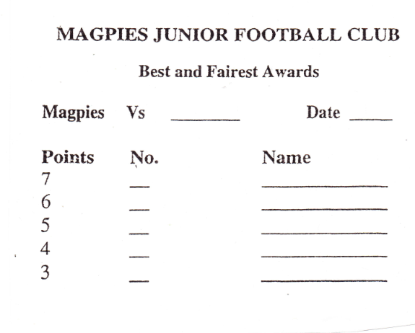

TEAM SHEETS
Filled in online via Sports TG. Must be submitted online by MIDNIGHT SUNDAY NIGHT
Please bring the votes envelope and team sheet hardcopy to the container on your training night following the game. There is a box there where they are kept.

